# Allied TECHCUT 4 Diamond Saw

**Standard Operation Procedure**

1. Diamond Saw Layout

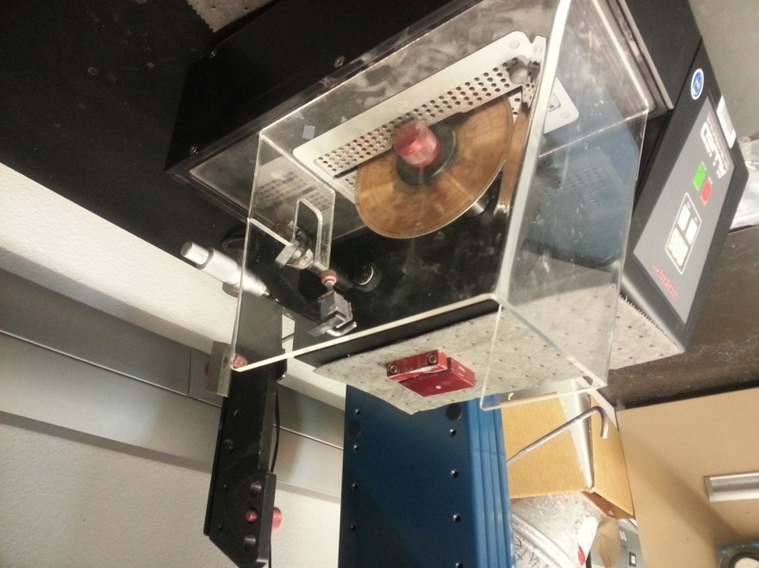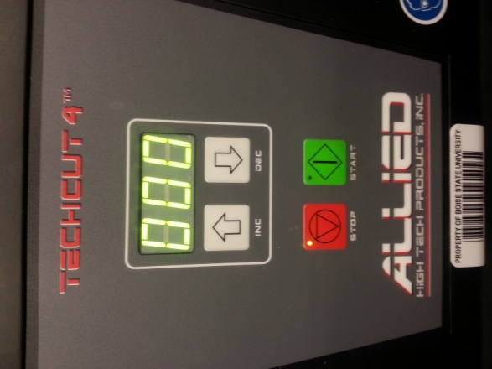

Stop and Start

Rotation Speed Control

Cutting Fluid Reservoir

Safety Shield

Diamond Blade

Control Panel

Sample Holder

Conditioning block

Lateral adjustment knob

Weights

Sample Holder Arm

1. Diamond Saw Operation
   1. Turn Diamond Saw on using switch located on the back.
   2. Position sample to cut in the sample holder and make sure it is secure.
   3. Remove safety shield.
   4. Attached sample holder to the right side of the sample holder arm with sample to cut sticking out of the right side.
   5. Put sample holder arm against diamond blade.
   6. Adjust the lateral adjustment knob to align blade with the desired cut location.
   7. Tighten sample holder on sample hold arm so that the sample sits at an angle on the front half of the diamond blade. (In front of orange line)
   8. Put sample holder arm back in the upright position
   9. Use arrows to set rotation speed (common speeds 100-250 rpm).
   10. Push green button to start diamond saw (nothing should be against the blade at this point)
   11. Manually push the conditioning block forward till the diamond blade cuts into it a distance equal to distance the blade will have cut through the sample (this should be repeated if it takes more than an hour to section the sample).
   12. Pull sample arm back down till the sample rests against (and starts being cut by) the diamond blade.
       1. The weights on the arm can be used to increase the cutting force
   13. Once sample has been sectioned, press the red button to stop the saw.
   14. Remove sample, clean up any spilled oil, and turn off the saw.
2. Replacing Cutting Fluid
   1. Ensure that everything is powered off.
   2. Using the included metal levers, place in each hole on the saw arm and loosen the blade.
   3. Remove clamps and blade and set them to the side.
   4. Slide out fluid reservoir, dispose of old fluid, clean out reservoir, refill with new cutting fluid.
   5. Replace fluid reservoir, replace clamps and blade and tighten with levers.
   6. Clean up any spilled cutting fluid.

If you have any questions, ask for assistance.